Lab 11: CRD

Four different designs for a digital computer circuit are being studied to compare the amount of noise present. The following data have been obtained:

|  |  |  |  |  |  |
| --- | --- | --- | --- | --- | --- |
| Circuit Design | Noise Observed | | | | |
| 1 | 19 | 20 | 19 | 30 | 08 |
| 2 | 80 | 61 | 73 | 56 | 80 |
| 3 | 45 | 26 | 25 | 35 | 50 |
| 4 | 95 | 46 | 83 | 78 | 97 |

1. Carryout one-way ANOVA to determine whether same amount of noise present for all four designs? Use α =0.05
2. Which circuit design would you select for use? Low noise is best.

Solution:

**Hypothesis**

|  |  |
| --- | --- |
| Null hypothesis | All means are equal |
| Alternative hypothesis | Not all means are equal |
| Significance level | α = 0.05 |

*Equal variances were assumed for the analysis.*

**Factor Information**

|  |  |  |
| --- | --- | --- |
| **Factor** | **Levels** | **Values** |
| Circuit Design | 4 | 1, 2, 3, 4 |

Test of significance of factor level

**Analysis of Variance**

|  |  |  |  |  |  |
| --- | --- | --- | --- | --- | --- |
| **Source** | **DF** | **Adj SS** | **Adj MS** | **F-Value** | **P-Value** |
| Circuit Design | 3 | 12102 | 4033.9 | 22.18 | 0.000 |
| Error | 16 | 2910 | 181.9 |  |  |
| Total | 19 | 15012 |  |  |  |

**Conclusion**: Since p-value (0.000) is less than significance level (0.05), we strongly reject H­0 in favour of H1 at 5 % level of significance. Hence, there is a significant difference in the mean noise levels of circuit designs.

**Model Summary**

|  |  |  |  |
| --- | --- | --- | --- |
| **S** | **R-sq** | **R-sq(adj)** | **R-sq(pred)** |
| 13.4870 | 80.61% | 76.98% | 69.71% |

Conclusion: The reliability of linear model for CRD is 76.98 %. We are 76.98 % confidence in predicting noise level knowing the circuit type, using linear model.

**Means**

|  |  |  |  |  |
| --- | --- | --- | --- | --- |
| **Circuit Design** | **N** | **Mean** | **StDev** | **95% CI** |
| 1 | 5 | 19.20 | 7.79 | (6.41, 31.99) |
| 2 | 5 | 70.00 | 11.02 | (57.21, 82.79) |
| 3 | 5 | 36.20 | 11.17 | (23.41, 48.99) |
| 4 | 5 | 79.80 | 20.51 | (67.01, 92.59) |

*Pooled StDev = 13.4870*

Conclusion: The table shows that circuit 1 has lowest mean noise level (best design) and circuit 4 has highest mean noise level (worst design)

Pairwise Comparision

**Grouping Information Using the Tukey Method and 95% Confidence**

|  |  |  |  |
| --- | --- | --- | --- |
| **Circuit Design** | **N** | **Mean** | **Grouping** |
| 4 | 5 | 79.80 | A |  |
| 2 | 5 | 70.00 | A |  |
| 3 | 5 | 36.20 |  | B |
| 1 | 5 | 19.20 |  | B |

*Means that do not share a letter are significantly different.*

Conclusion: On performing pairwise comparison, we found two clusters or groups: Group A includes circuit design 2 and 4 (similar effects) and group B includes circuit design 1 and 3 (similar effects)

Mean plot

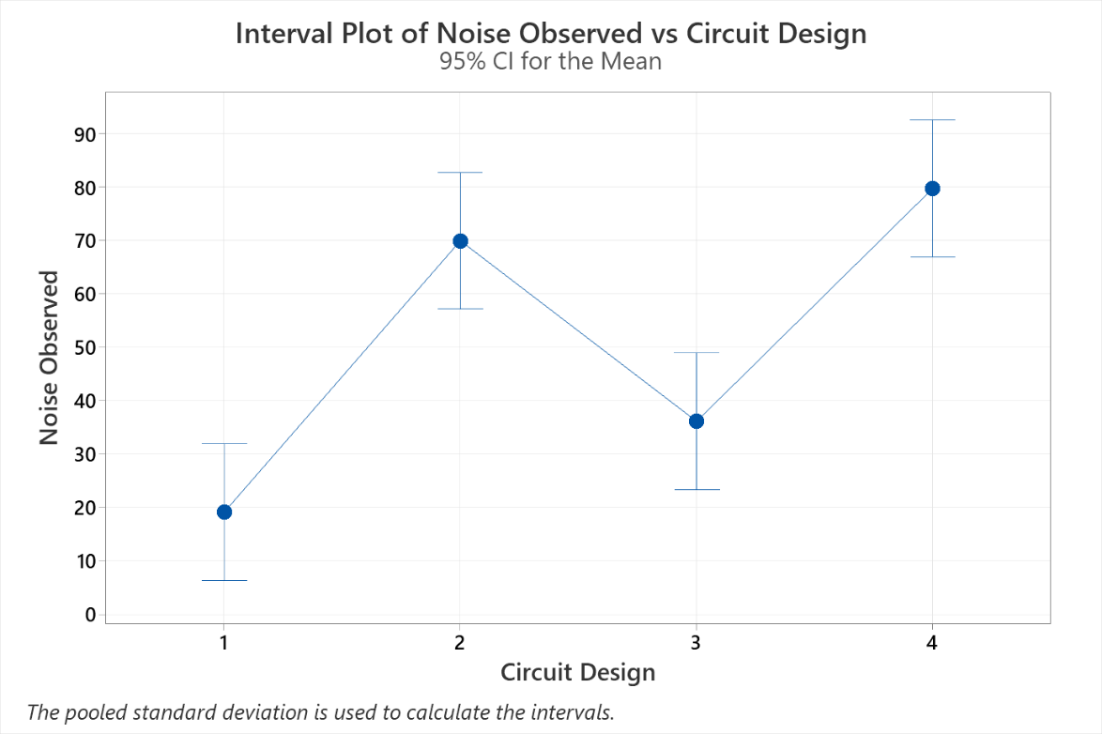

Residual Analysis

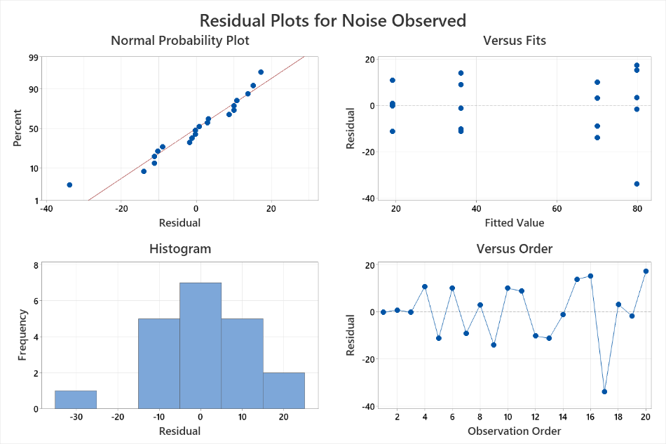

Conclusion:

1. The graph 1 and 3 shows that the assumption of normality of error distribution is not satisfactorily met.
2. The graph 2 shows that variance of distribution of errors have same variance across different levels of primary factor (reference line is e = 0), however there is one potential extreme value.
3. The graph 2 also shows that the linear model is valid for CRD, as the pattern of dots above and below the reference line e = 0 is random
4. The graph 4 which the graph of errors plotted against observation order, shows that there no obvious pattern of dots below and above the reference line e = 0. Hence, assumption of independence errors is valid.